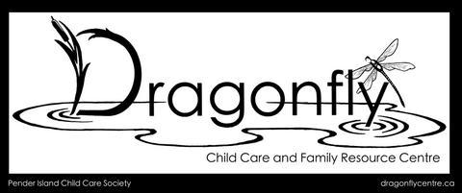
Dragonfly Child Care & Family Resource Centre
Job Posting – Early Childhood Educator (ECE)
Are you ready for a meaningful career move and a lifestyle change? Join us on beautiful Pender Island, where a close-knit community, and a slower pace of life create the perfect backdrop for both personal and professional growth.
Dragonfly Child Care & Family Resource Centre (Pender Island Child Care Society) is seeking a passionate and dedicated Early Childhood Educator (ECE) for a one-year term at our unique childcare centre. Located on the Pender Island Elementary and Secondary School grounds, our program offers access to the school gym, natural outdoor spaces, and forested areas—an inspiring environment for both children and educators.
We are a child lead and nature-based program, committed to accessibility, inclusion, and high-quality early learning for all families. Our workplace culture is built on support, positivity, and teamwork—we are a fun, collaborative team that truly values each member. If you’re looking for more than just a job—and want to be part of a vibrant island community while making a difference in children’s lives—we’d love to hear from you!
Position Overview
Reporting to the Facility Manager, the ECE provides nurturing care, leadership, and support to ensure a safe and engaging environment for children. You will work in alignment with Dragonfly’s philosophy and adhere to all BC Child Care Licensing Regulations, while collaborating closely with a strong and supportive team.
Key Responsibilities
- Plan and implement developmentally appropriate activities indoors and outdoors
- Provide attentive care including diapering, toileting, feeding, and napping
- Use positive guidance and preventative discipline strategies
- Foster strong, respectful communication with families
- Maintain required licensing records and documentation
Minimum Qualifications
- Valid Early Childhood Education (ECE) Certificate (required)
- Experience working in a group care setting with children age 36 months to 5 years
- Emergency Child Care First Aid with CPR
- Criminal Record Check
- Strong interpersonal and teamwork skills
- Respect for diversity and inclusive practices
- Energy and ability to meet the physical demands of the role
- Commitment to high-quality programming and a positive workplace
- Strong problem-solving and conflict resolution skills
Position Details
- Start Date: May 19, 2026 (can be flexible)
- Hours: 33 hours per week (Tuesdays – Fridays)
- Wage: starting at $28.50 per hour, also based on education and experience
- Benefits: extended health and dental coverage available after 3 months
- Assistance with finding housing is available for the right candidate
How to Apply
Please submit your application to: dragonflyfamilycentre@gmail.com
**Important: We will only respond to applicants who:
- Clearly state their intention to relocate to Pender Island, and
- Hold a valid ECE certification

